# Thailand Water Supply System

**Senior Project 1**

Stephen Bonk (Team Leader)

Kevin Dischino

Joseph Moore

Advisor - Dr. Horst

November 2012

# Thailand Water Supply System

A Senior Design for Senior Project I Submitted to the Faculty of The College of New Jersey

By Stephen Bonk, Kevin Dischino and Joseph Moore

In partial fulfillment of the degree of Bachelor of Science in Civil Engineering

November 28, 2012

# Abstract

The overall goal of the Thailand Water Supply System project was to pump, store and distribute water to Hantham Village in Long Khot Thailand. The village encompasses 453 people living in 159 households. The first portion of the project was to design a pumping system to push water from an existing well to a series of storage tanks. The second segment was to design both the storage tanks and a concrete slab foundation to support these tanks. Finally, the third part of the project was to design a distribution system to provide each of the 159 households with water.

The storage tanks designed were located such that the difference in elevation between the tanks and the highest point on the distribution system is 3.99 meters. This provides the highest point on the distribution system with 4 psi under dynamic conditions during the maximum hourly demand for the year. A soil sample was collected on an assessment trip in May 2012, which was analyzed and determined to be clayey or silty soil with a unit weight of 105 lb/ft3 and an angle of friction equaling 30o. The percent of clay in the Thailand soil sample was found to be 16.75 %. The bearing capacity of the soil was calculated to be 13062.84 lb/ft2. There will be three different types of piping, the main line, the pipes on each of the small roadways, and the pipes branching into each individual house. The preliminary design of the upper portion of the village, which includes 30 houses, was found to have total headlosses of 3.025 feet or 0.079 feet, if 1” or 2” diameter piping is used, respectively.

The senior project group is anticipating traveling to the village in May 2013 to implement the design. This system will provide enough water so that the villagers no longer have an inadequate supply during their dry season. The group will also be making a universal Operations and Maintenance Manual which can be read and understood by the villagers.

Table of Contents

[Abstract I](#_Toc342993054)

[List of Figures IV](#_Toc342993055)

[List of Tables IV](#_Toc342993056)

[Introduction 1](#_Toc342993057)

[Team Management 2](#_Toc342993058)

[Specifications 3](#_Toc342993059)

[Background 4](#_Toc342993060)

[Technical Content 5](#_Toc342993061)

[Hydraulics Design 5](#_Toc342993062)

[Overview 5](#_Toc342993063)

[Analysis 5](#_Toc342993064)

[Results 11](#_Toc342993065)

[Conclusion 12](#_Toc342993066)

[Geotechnical and Storage Tank Design 13](#_Toc342993067)

[Overview 13](#_Toc342993068)

[Analysis 13](#_Toc342993069)

[Results 14](#_Toc342993070)

[Conclusion 17](#_Toc342993071)

[Water Distribution System Design 18](#_Toc342993072)

[Overview 18](#_Toc342993073)

[Analysis 18](#_Toc342993074)

[Results 21](#_Toc342993075)

[Conclusion 22](#_Toc342993076)

[Conclusion 23](#_Toc342993077)

[List of References 24](#_Toc342993078)

[Appendix 25](#_Toc342993079)

[Appendix A: Project Overview 26](#_Toc342993080)

[Team Biographies 26](#_Toc342993081)

[Engineering standards and realistic constraints form (signed and dated) 27](#_Toc342993082)

[Engineering standards and realistic constraints presentation 28](#_Toc342993083)

[Engineering standards, specifications and codes (list by name) 29](#_Toc342993084)

[Modern engineering tools (list by name) 29](#_Toc342993085)

[Appendix B: Team Management 30](#_Toc342993086)

[Gantt chart 30](#_Toc342993087)

[Meeting minutes (example) 30](#_Toc342993088)

[List of contacts 31](#_Toc342993089)

[Safety essay 31](#_Toc342993090)

[Material list 31](#_Toc342993091)

[Financial budget (include all expenses including travel) 32](#_Toc342993092)

[Appendix C: Moody Diagram 33](#_Toc342993093)

[Appendix D: Topographic Data Map 34](#_Toc342993094)

[Appendix E: System Head Curve Calculations 35](#_Toc342993095)

[Appendix F: WaterCAD Output 37](#_Toc342993096)

[Appendix G: Evaluations 39](#_Toc342993097)

# List of Figures

[Figure 1 – Water Demand Prediction 6](H:\\Senior Project\\Thailand Water Supply System Report Draft-horst.docx" \l "_Toc342992746)

[Figure 2 – Flow Diagram 8](H:\\Senior Project\\Thailand Water Supply System Report Draft-horst.docx" \l "_Toc342992747)

[Figure 3 – Path of Water from Tank to Most Critical Point 8](H:\\Senior Project\\Thailand Water Supply System Report Draft-horst.docx" \l "_Toc342992748)

[Figure 4 – 1 Inch Pipe System Head Curve (well to storage tank) 9](H:\\Senior Project\\Thailand Water Supply System Report Draft-horst.docx" \l "_Toc342992749)

[Figure 5 – 2 Inch Pipe System Head Curve (well to storage tank) 10](H:\\Senior Project\\Thailand Water Supply System Report Draft-horst.docx" \l "_Toc342992750)

[Figure 6 - 3 Inch Pipe System Head Curve (well to storage tank) 10](H:\\Senior Project\\Thailand Water Supply System Report Draft-horst.docx" \l "_Toc342992751)

[Figure 7 – Sieve Analysis 14](H:\\Senior Project\\Thailand Water Supply System Report Draft-horst.docx" \l "_Toc342992752)

[Figure 2 - Soil Properties 15](H:\\Senior Project\\Thailand Water Supply System Report Draft-horst.docx" \l "_Toc342992753)

[Figure 8 - Soil Properties 18](H:\\Senior Project\\Thailand Water Supply System Report Draft-horst.docx" \l "_Toc342992754)

[Figure 12 - Schematic of Upper Section 19](#_Toc342992755)

[Figure 13 - WaterCAD Schematic for 2” and 3/4" pipes 20](#_Toc342992756)

[Figure 14 - WaterCAD Schematic for 2” and 3/4" pipes 21](#_Toc342992757)

# List of Tables

[Table 1 – Water Usage Characteristics 11](#_Toc342992734)

[Table 2 – Pipe “A” Design 11](#_Toc342992735)

[Table 3 – Head Losses From Tank to Most Critical Point 11](#_Toc342992736)

[Table 4 – Tank Locations and Water Pressure 11](#_Toc342992737)

[Table 5 - Hand Calculation Results for the Upper 30 houses 21](#_Toc342992738)

[Table 6 - WaterCAD 2” Piping Headloss 22](#_Toc342992739)

# Introduction

 The goal of the project was to design a water storage system for Hantham Village in Long Khot, Thailand. There is an existing water tower in the village, but it is inadequate during the dry season. The village consists of 453 people living in 159 households. Each household uses approximately 200 liters of water per day, or 52 gallons.

There were two different design options that were considered for this project. The first option was to design one large rectangular concrete storage tank which was gravity fed to each household through a distribution system or a circular concrete tank would be utilized.  A design for an appropriate pump was needed to push the water from the existing well in the village to the storage tanks. A distribution system to transport the water from the tanks to each of the 159 households was also developed. Lastly, the foundation was be analyzed that these storage tanks will rest on. A sample and layout of the soil was obtained during an assessment trip to the area in May 2012, and was used as design parameters. Along with the storage system, an Operations and Maintenance Manual will be needed that can be read universally.

Fundraising for this project will last throughout the year with the help of the TCNJ Humanitarian Engineering chapter.  It is anticipated that the   project will be implemented May of 2013.

# Team Management

The Thailand Water Supply System consists of three distinct parts. Kevin designed the hydraulics portion, Joseph was in charge of the geotechnical work as well as the design of the storage tanks, and Stephen was the team leader and responsible for the design of the water distribution system. The hydraulics section was comprised of determining the appropriate pump to push the water from the well to the storage tanks. The elevation of the storage tanks also had to be checked by analyzing the pressure at the most critical point in the distribution system. The geotechnical section of the project was to design a concrete slab foundation and also design the storage tanks. Finally, the water distribution system design consisted of selecting an appropriate layout and sizes for the pipes, and then analyzing that system. Each team member showed tremendous ambition as they were determined to create the best possible design for Hantham Village.

The team met weekly to discuss what each member had contributed recently. It was important to make sure that each member was putting in valuable work each week so that nobody fell behind. Meetings were held every Friday with our primary advisors, and every Tuesday with the geotechnical discipline advisor. During these meetings, which usually lasted around 30 minutes, the group’s progress was reported and the respective advisors gave recommendations or criticism on how the design was developing. The structural discipline advisor was also met with to present the progression of the concrete storage tank design. Minutes were kept for each meeting with the primary advisor and an example of these can be seen in Appendix X.

# Specifications

The goal of the Thailand Water Storage System Project is to provide the village of Long Khot with a perennial supply of clean water. The village contains 453 people and 159 households. As stated by the village leaders, each household uses approximately 6 cubic meters of water per month. The pumping system should be able to exceed the water usage. The water should be pumped from the pre-existing well at a depth such that impurities are minimized. The pumping system should be sustainably powered. The storage tank will be a covered reinforced concrete tank resting on a reinforced concrete foundation, placed at a location such that the water pressure at the most critical household on the distribution system will be sufficient. The tank and foundation will be designed with a high factor of safety to ensure long life span, minimize maintenance and to prevent failure. The distribution system will be designed to minimize head losses while balancing economy.

# Background

The College of New Jersey Humanitarian Engineering club has had an ongoing relationship with Dr. Shafer, the leader of a WarmHeart orphanage in Thailand. Through Dr. Shafer we learned of the developing village of Long Khot in Thailand. The village of Long Khot has a shortage of clean water during the dry season and is in need of water storage system to supplement their current supply. In May of 2011, TCNJ Humanitarian Engineering traveled to Long Khot to perform a site assessment for the project. During the site assessment trip topographical data, water usage characteristics, and soil data were gathered. Additionally, the club spoke with the leaders of the village to determine existing resources available to the village and overall feasibility of the project. It was determined that village was in possession of an unused well on the side of a mountain above the village center and has a somewhat unreliable 220 volt power source available. Additionally, the village leaders stated that the village would provide labor for the construction of the system. TCNJ Humanitarian Engineering agreed to take on the project and is currently in the process of fundraising and design. The club anticipates implementing the project in May of 2013.

# Technical Content

## Hydraulics Design

### Overview

The water resources design of the water storage system for Long Khot involves several aspects. The determination of the water usage characteristics of the village was the first aspect that was completed. While on the site assessment trip, water usage data was obtained from the village leaders. This data was used in the estimation of further water usage characteristics. The next task was to design the pipe that will connect the storage tanks to the distribution system. While on the site assessment trip, data was collected about the path along which this pipe would be laid, including distance, households serviced, and elevations. The next task was to select a tank location. Survey data, including elevations of possible site locations and pipe and flow characteristics along the path water takes from the tanks to the most critical point on the distribution system were collected during the site assessment. The tank location was selected such that the most critical point on the distribution system will receive sufficient water pressure during the peak demand hour of the year. The pumping system is the next component that will be designed. Design of the pumping system has not yet been completed. So far data from the site assessment trip including well depth and ground water table elevation have been used to generate System Head Curves for a range of pipe diameters. Future design work includes, finalizing the selection of the pumping system, writing an operations and maintenance manual and a detailed budget.

### Analysis

Water usage data provided by the village of Long Khot included the number of households in the village serviced by the distribution system and an average volume of water of 6 cubic meters per month consumed by each household. The volume of water used by the entire village daily was determined to be 1,123 cubic feet per day. It was determined that a 3 day water supply contained in the storage tanks would provide enough time for repairs if the pumping system or distribution system were to break. This led to a total tank volume of 3,369 cubic feet.

From the average flow per month provided by the village, an average annual flow of 0.012998 cfs for the entire village was calculated. This number was used to find the maximum hourly flow per year for the entire village. From the following empirical relations, maximum daily flow per year equals 180% of average annual flow and maximum hourly flow per year equals 150% of maximum daily flow per year (Chin, figure 3.23), it can be determined that the maximum hourly flow per year equals 270% of the average annual flow. Using this relationship, the maximum hourly flow per year for the entire village was calculated to be 0.0351 cfs. This value was used in the design of the pipe connecting the tank to the distribution system, as it predicts the maximum expected head losses in the peak demand hour of the year.

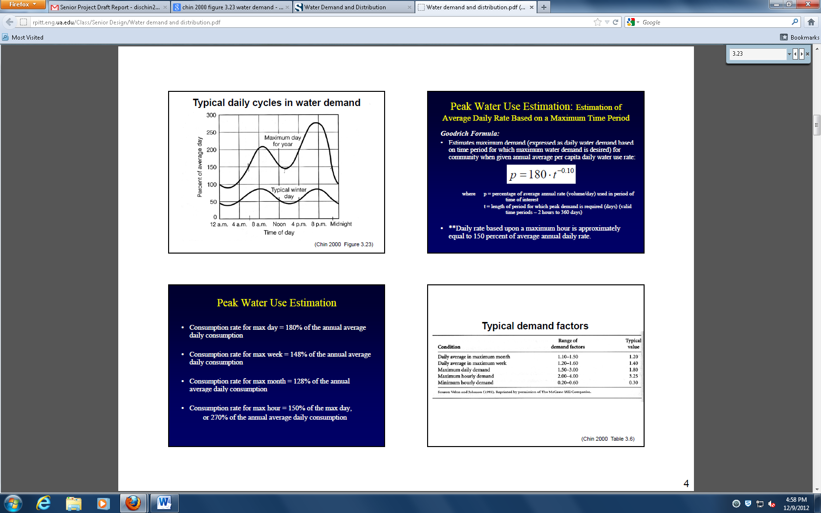

Figure 1 – Water Demand Prediction

The design of the pipe connecting the storage tanks to the distribution system began by first assuming a maximum velocity of 10 fps in the pipe. Using the continuity equation, it was determined that during the maximum hourly flow per year, the pipe diameter would have to be greater than 0.8 inches to ensure the velocity would remain below 10 fps. A high water velocity in the pipe could lead to more rapid deterioration and breaking of the pipe, especially at bends.

After a minimum diameter was determined, the pipe’s actual diameter could be selected. 1 inch, 2 inch, and 3 inch diameter pipe designs were analyzed. First, the head losses in the pipe were calculated using the Darcy Weisbach equation for major head losses (Equation 1), and the minor loss equation (Equation 2). Major head losses were then calculated for 1 inch, 2 inch and 3 inch diameter pipes. A roughness coefficient for PVC pipe of 6 x 10-5 inches was used. The velocities in the pipes were calculated using the continuity equation. The Reynolds numbers were calculated using the kinematic viscosity of water of 1.21 x 10-5. The Reynolds Numbers and roughness coefficients were used to determine the friction factors for the different diameter pipes with the Moody Diagram (Appendix C). It was determined that for 1 inch diameter the major head losses would be 323.5 feet, for a 2 inch diameter the major head losses would be 11.72 feet, and for a 3inch diameter the major head losses would be 1.7 feet during the maximum hourly demand per year. The minor head losses were then calculated for two 90o threaded bends and an entrance for the 3 inch diameter pipe. It was determined that the minor losses in the 3 inch diameter pipe would be 0.032 feet. Because the total head loss in the 3 inch diameter would be approximately 1.73 feet, it was selected as the final diameter. Any further increase in diameter would increase the cost unnecessarily while causing a fairly negligible reduction in head losses.

$h_{L}=f\frac{l}{D}\frac{v^{2}}{2g}$ Equation 1

Where:

f = Friction Factor

L = Length of Pipe (ft.)

D = Diameter of Pipe (ft.)

V = Velocity (f/s)

G = Gravitational Constant (32.2 ft/s2)

Where:

Kl = Minor Loss Coefficient

V = Velocity (f/s)

G = Gravitational Constant (32.2 ft/s2)

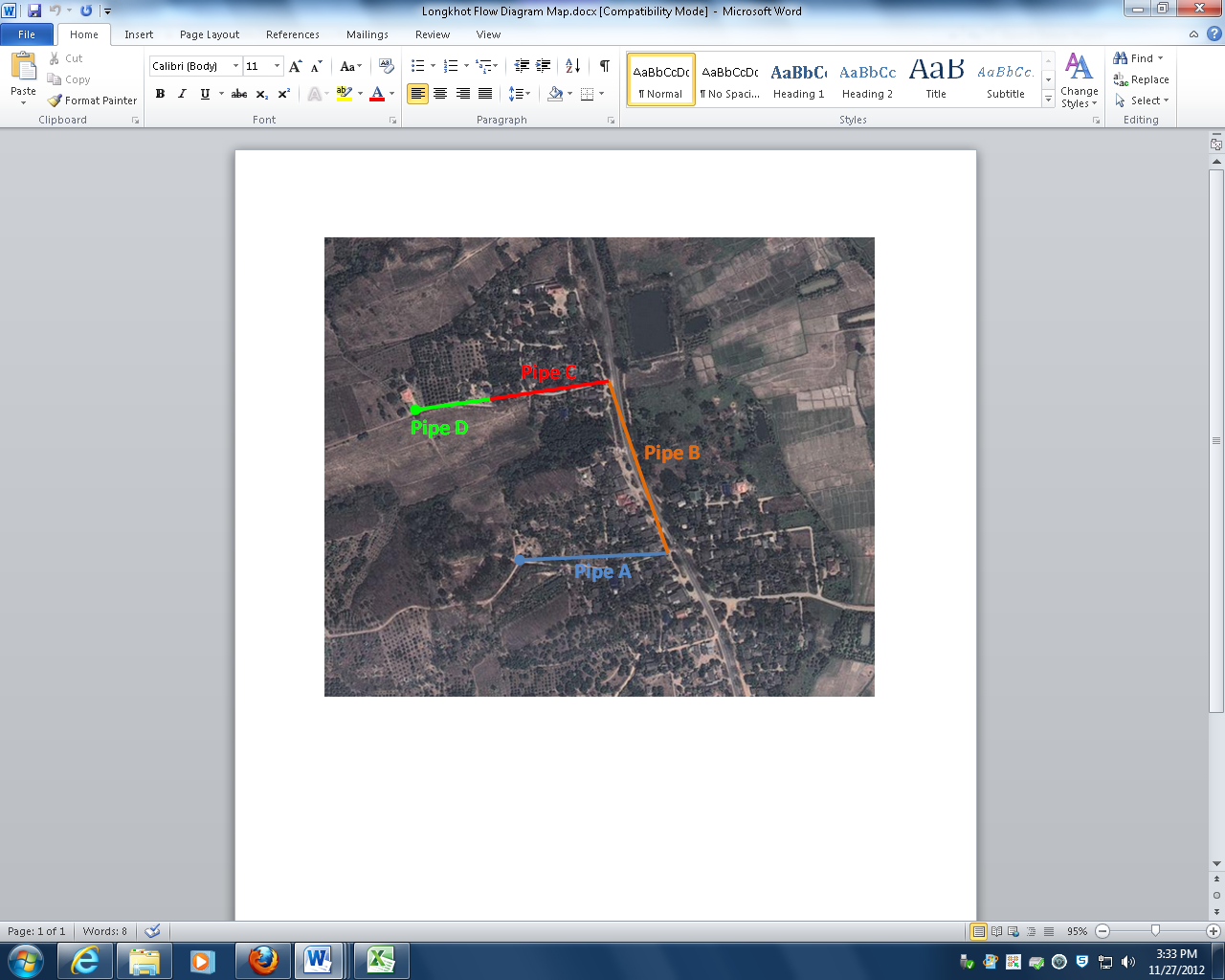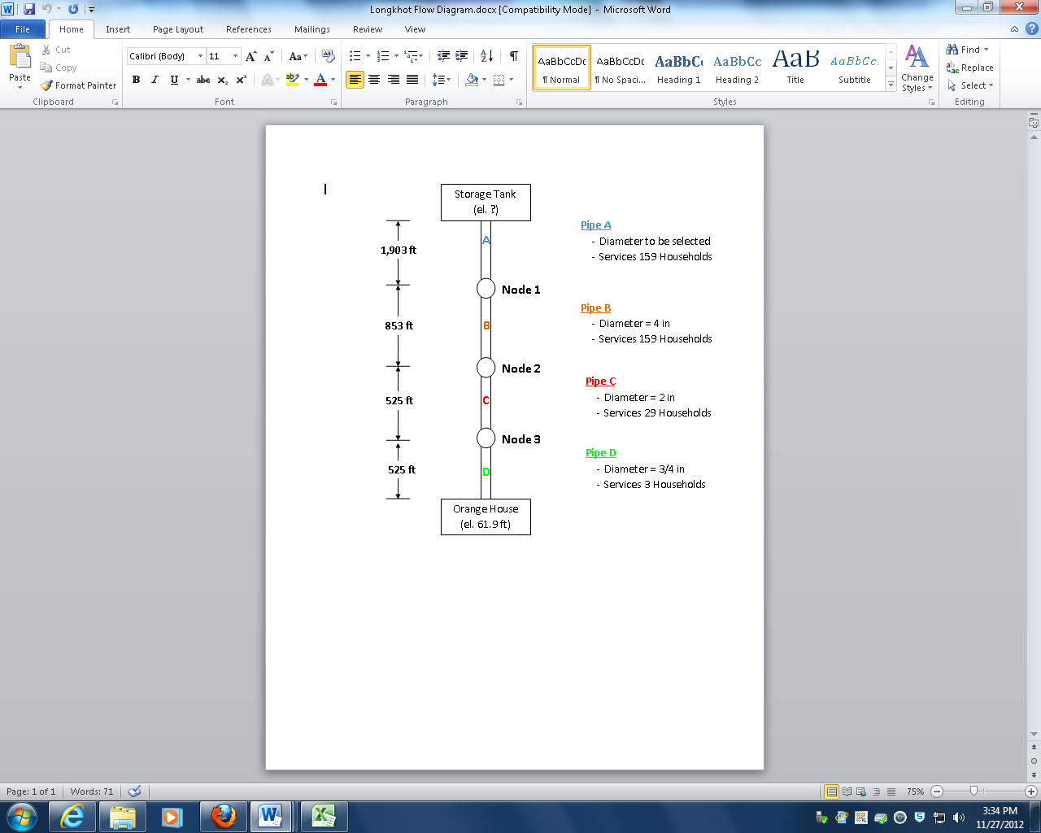Next, a simplified flow diagram was created to delineate the path water would take through the distribution system from the storage tank to the highest and most critical household. The flow diagram of this path can be seen in figure 2 and the map of the path can be seen in figure 3. Pipe A is the pipe that connects the storage tank to the distribution system, with the selected diameter of 3 inches. All of the data for pipes B, C and D, including pipe lengths, diameters and number of households serviced, was collected on the site assessment trip. To design for the worst case scenario, the flow in the pipes was determined by the total number of households that were eventually serviced by the pipe itself or any pipes connected to it further down the distribution system. It was assumed that the flow to the households that each pipe services would exit only at nodes at the end of each pipe. In reality the flow decreases incrementally along the pipe as branches deliver water to each household. Assuming that the flow only exits at the nodes allows for a simplified and conservative calculation of the head losses.

To determine the elevation of the storage tanks that would allow for sufficient water pressure at the most critical point on the distribution system (the orange roof house at the end of pipe D – see figures 2 and 3) Bernoulli’s equation (Equation 3) was solved for the path from the storage tank to the orange roof house. The head losses in each pipe were determined using the same process described earlier, using the maximum hourly flow per year. The total major and minor head losses were determined by summing the head losses in each pipe along the path analyzed (Equation 4 and 5). Solving Bernoulli’s equation, it was determined that possible tank sites 1 and 2 would not allow for any water to reach the most critical point. If the tanks were located at site 3 (elevation 86.3 feet assuming the village main road is at elevation 0), then the most critical point would receive 4 psi under dynamic conditions during the maximum hourly flow per year (see Appendix D for map). This water pressure was deemed sufficient, considering this house is much higher in elevation than the rest of the village.

Figure – Flow Diagram

Figure – Path of Water from Tank to Most Critical Point

Where:

P = Pressure (lb/ft2)

= Specific Volume (lb/ft3)

V = Velocity (ft/s)

Z = Elevation (ft)

= Major Head Loss (ft)

Where:

= Major Head Loss in Pipes A, B, C, and D

Where:

= Minor Head Loss in Pipes A, B, C, and D

The first step in the design of the pumping system was to determine if a single submersible pump, located at the ground water table in the well would be sufficient to pump the water up to the tanks. To do this, system head curves were created by solving Bernoulli’s equation for the pump energy (Equation 6) for 1 inch, 2 inch, and 3 inch diameter pipes at a range of flows from 0 to 0.05 cfs (Figure 3, 4 and 5). Head losses were solved for using the process described earlier. These system head curves will then be compared to manufacturer specifications for various submersible pumps. Currently, Sunwise Technologies is assisting us with the sizing of a Grundfos SQ Flex submersible pump with a solar panel power system. The calculation for the system head curves can be seen in Appendix E. The pumping system and size has not yet been determined.

Where:

= Pump Energy (ft)

V = Velocity (ft/s)

Z = Elevation (ft)

$h_{L}$ = Major Head Loss (ft)

$h_{m}$ = Minor Head Loss (ft)

Figure 4 – 1 Inch Pipe System Head Curve (well to storage tank)

Figure 5 – 2 Inch Pipe System Head Curve (well to storage tank)

Figure 6 - 3 Inch Pipe System Head Curve (well to storage tank)

### Results













Table 1 displays the water usage characteristics for Long Khot, calculated from data provided by the village and empirical relationships.

Table 1 – Water Usage Characteristics

|  |  |
| --- | --- |
| Average Annual Flow (cfs) | 0.012998 |
| Maximum Hourly Flow Per Year (cfs) | 0.00351 |
| Volume of Storage Tank (cf) | 3,369 |

Table 2 displays the major head losses calculated for pipe “A” in the design process. A 3 inch diameter was selected based on the minimal head losses.

Table 2 – Pipe “A” Design

|  |  |
| --- | --- |
| Pipe “A” Diameter (in ) | Major Head Losses (ft) |
| 1 | 323.5 |
| 2 | 11.7 |
| 3 (selected diameter) | 1.7 |

Table 3 displays the major and minor head losses calculated for each pipe that water travels through from the storage tank to the highest and most critical household on the distribution system.

Table 3 – Head Losses From Tank to Most Critical Point

|  |  |  |
| --- | --- | --- |
| Pipe | Major Head Losses (ft) | Minor Head Losses (ft) |
| A | 1.7 | 0.032 |
| B | 0.2 | 0.035 |
| C | 0.16 | 0.014 |
| D | 0.3 | 0.003 |
| Total Head Losses | 2.36 | 0.82 |

Table 4 displays the water pressure for the most critical household on the distribution system calculated using Bernoulli’s Equation for assuming the storage tank was located at each of the 3 sites. It can be seen that Sites 1 and 2 are inadequate. If the tanks are placed at Site 3, the highest possible location, then the most critical household will receive 4 psi under dynamic conditions during the maximum hourly flow per year, the worst case scenario.

Table 4 – Tank Locations and Water Pressure

|  |  |
| --- | --- |
| Tank Locations | Water Pressure (psi) |
| Site 1 | 0 |
| Site 2 | 0 |
| Site 3 | 4 |

.

### Conclusion

Presently, it has been determined that the tanks should be located at site 3, with the bottom of the tanks at an elevation of 86.3 feet above the main road of the village. The tanks will have a storage volume of 3,369 cubic feet, allotting for a 3 day supply of water. The 3 day supply will ensure that the village will have a water supply for an adequate amount of time to make any repairs to the pumping system or distribution system. It has also been determined that a 3” diameter pipe will be used to connect the storage tanks to the distribution system. In the future, design of the pumping system will be completed, a detailed budget will be created and an operations and maintenance manual will be written. Currently, we are communicating with Sunwise Technologies regarding the Grundfos SQ Flex Solar Submersible Pump.

**Geotechnical and Storage Tank Design**

**Overview**

The geotechnical and storage tank design part of the project contained the analysis of soil and two designs of a concrete tank. A 33.14 gram soil sample was collected from the second highest flat area in the village. A sieve analysis was needed to classify and get soil properties for design calculations. This made it possible to know if the soil was adequate enough to hold the load of water and concrete of the storage tank. The concrete tank was designed to hold 25,201.87 gallons of water. This was the amount of water needed to have a three day supply of water for Longkhot, Thailand. A three day supply would make sure the village would not run out of water during the dry season. A village of 453 people living in 159 households was considered for the design. The concrete tank had to connect to the designed water system. The concrete tank designs were a rectangular retaining concrete wall and a circular retaining wall. The retaining concrete tank wall will be connected to a foundation slab that will be 12 inches thick. A slab foundation was selected because it will uniformly settle unlike spread footings. The soil properties calculated were conservative because of the uncertainty of the small sample size. The design was made so it would be possible for the villagers to be able to build it easily.

**Analysis**

A soil sample was brought back from the EWB implementation trip in Thailand in May 2011. The soil sample was used to analyze the soil to find the soil properties of the area. The soil sample was collected at ground level and near the proposed design site. A sieve analysis was performed on the soil sample to find percentages of fines and sand. The sieve analysis was performed twice to get the most accurate results for the small soil sample. The percent of fines in the soil was important in classifying the soil in terms of USCS classification. Soil properties were estimated based on the results of the sieve analysis test. After the soil properties were determined it was possible to utilize a spreadsheet to determine factor of safety against bearing capacity. The spreadsheet utilized the size of the concrete tank being designed and the weight of the water. The dead weight of the concrete and water were lateral loads on the foundation. The excel spreadsheet calculated the factor of safety for the estimated soil properties to be over 15. This meant that the soil was more than adequate to handle a concrete tank filled with 25,201.87 gallons of water. The soil sample was assumed to have a great amount of error in moisture content because it was a small sample. The minimum characteristics the soil needed to have to still be over a factor of safety of over 4.5 were calculated because this would be conservative enough for the situation. The soil properties were calculated to be a unit weight of 80 psf and friction angle of 28o. After all of the soil characteristics were determined to be adequate, the designs of the concrete tanks were started. First, the rectangular concrete cantilever retaining wall was designed to have enough reinforcement and concrete to hold 25,201.87 gallons of water. The compressive force of the concrete was assumed to be only 3000 psi because only low strength concrete is available in Thailand. Then a circular concrete tank will be designed for a final consideration. A circular tank is more economical and feasible. The final decision on the design will be after both designs are completed.

**Results**

A sieve analysis was performed on a 33.14 gram soil sample collected from Longkhot, Thailand. After the sieve analysis was performed soil parameters were estimated. The unit weight was estimated to be 105 lb/ft3. This was determined because of the distribution of soil from the sieve analysis. This unit weight is within the range of unit weight for clayey sands. Also the size of the sample was lower than the recommended amount of soil for a sieve analysis. Soil Mechanics Laboratory Manual recommended 500 grams of soil for a sieve analysis. Using the sieve analysis data the friction angle was determined to be 30o using average friction angle for silty sand. Thirty degrees was used to be conservative. These soil parameters were used to classify the soil in terms of the USCS classification to be Silty or Clayey Sand by following the united soil classification system. Figure 6 shows that the soil is not well graded. A sand is considered well graded if the uniformity coefficient is greater than 6 and the coefficient of Curvature is between 1 and 3. The calculated uniformity coefficient, Cu was 3.833 and the coefficient of curvature, Cc was calculated to be .586957. 16.75 % of the soil was determined to be clay.

Figure 7 – Sieve Analysis

Using all of the soil parameters found from the sieve analysis, an excel spreadsheet to find the factor of safety for the soil after being loaded with the storage tank and water was utilized. The first soil properties calculated were found using the best engineering judgment possible after the sieve analysis. The found soil properties were a unit weight of 105 psf, a friction angle of 30o and no cohesion. The second soil properties were found with an excel spreadsheet to estimate the minimum unit weight and friction angle needed to achieve a factor of safety against bearing capacity. For the first estimated soil properties it was found that the soil had a bearing capacity of 13062.8 lb/ft2 and a factor of safety of 16.09. The second or minimum soil properties of the soil have to have a unit weight of 80 lb/ft3 and a friction angle of 28o. I found these soil properties by trial and error to find the worst soil properties possible. With the excel spreadsheet, the minimum soil parameters yielded a bearing capacity of 3856 lb/ft2. Figure 7 shows the inputs of the excel spreadsheet for the minimum soil properties. The main inputs were the depth of embedment, dimensions of the tank, cohesion, unit weight, and friction angle. The depth of embedment was 2 feet to make sure overturning of the foundation would not happen.

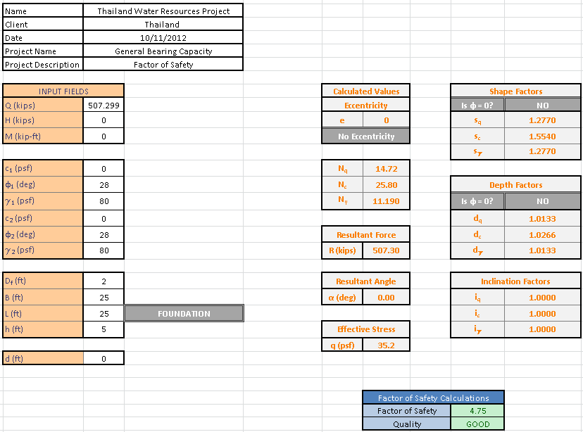The Thailand Village was estimated to have adequate soil properties even with a conservative approach on estimating. So overall, the soil will be adequate to hold the design of the concrete storage tank.

Figure - Soil Properties

Figure 8 – Minimum Soil Properties

The rectangular cantilever retaining concrete wall was designed to hold the 25,201.34 gallons of water. For the storage tank it was found that the wind load on the tank would be .014868 kips, meaning it was negligible and it did not have to be considered. The concrete tank also needed to be designed for overturning and sliding. The factor of safety had to be over 2.5 and 1.5, respectively. It was found that the self-weight of one of the retaining walls and the water pressure on the wall was 5265.15 lb. The resisting moment of the cantilever retaining wall was 19791.4 foot pounds. Using the friction of the toe, heel, key and the passive water pressure it was found that the total resistance to sliding was 3204.92 lb. The total resistance to sliding was utilized to find the factor of safety against sliding to be 4.81, which is greater than the suggested 1.5. For the arm and the key the reinforcement was determined to number 5 bars at 9 inches center to center and number 4 bars for resistance by alternate bars. For the toe slab, number 7 bars were designed to be used at 12 inches center to center for the reinforcement. Both parts were checked against shear and moment to be determined adequate. The end design will also take into consideration the heel slab reinforcement.



Figure 9 - Concrete Rectangular Cantilever Wall

The circular cantilever retaining wall will be used because of the ease of construction compared to the rectangular and need less concrete.

**Conclusion**

The soil of the village Longkhot, Thailand was analyzed to understand the area and design the storage tanks. The estimated soil properties were determined to have a unit weight of 105 lb/ft3 and a friction angle of 30o. Both of these are conservative based on the sieve analysis results and are around the average sand properties. There was 16.75 % clay in the 33.14 gram soil sample. The USCS classification was silty or clayey sand. The estimated soil properties produced a bearing capacity of 13062.84 psf. To be safe the minimum soil properties needed for the concrete tank to be safe were calculated because of the possible error of the analysis. The possible error of the soil analysis was imminent because of the small sample size. The minimum soil properties needed for the storage tanks to be sustainable were a unit weight of 80 lb/ft3 and 28o friction angle. These values are well below the estimated values of the soil properties. The minimum soil properties produced a bearing capacity of 3855.9 psf assuming a unit weight of 80 psf and a friction angle of 28o. To contain 25,201.34 gallons in one concrete tank a concrete rectangular cantilever retaining wall or a circular cantilever retaining wall needs to be constructed. The dimensions of the rectangular concrete tank would be 25’x25’x6’. The circular concrete tank will have an 18’ diameter. The circular concrete tank will be more advisable because less concrete is needed and is easier to build. The concrete tank will be placed near the government school because this is the only place where the head difference is great enough to give enough water pressure to the village. This is discussed in the water resources and hydraulics design part.The rectangular concrete tank will be sufficient enough to hold a three day water supply for the village. But a circular tank will be more economical and easier to construct. Through the use of 60,000 psi steel and 3,000 psi compressive strength of concrete an adequate solution of a circular concrete tank was found.

## Water Distribution System Design

### Overview

The overall goal of the Water Distribution portion of the project was to design the most appropriate layout and sizing of piping to supply water to the village. The diameter of each pipe was selected by comparing the head loss from each section to the economic constraints of the village. The village of Long Khot is one of the poorer subsets of Thailand, so the cost to implement and maintain this project had to be reasonable. So far, the upper portion of the village containing 30 of the 159 households was designed through both hand calculations and the use of WaterCAD software. These results were analyzed and compared. The pipe diameters were determined to be 3” for the main line coming from the storage tank in the Hydraulic Design Chapter, 4”for the line running along Route 1001, 2” for the pipes along each minor road, and 3/4” pipes branching from the 2” pipes to each of the households. Hand Calculations for the 2” pipes servicing the 30 households yielded a head loss of 0.079 feet, while WaterCAD found it to be 0.0665 feet. These head losses in the 2” pipes were totaled solely for the comparison of hand calculations to WaterCAD software. The total head loss in the system from the storage tanks to any of the 30 individual homes can also be determined by adding the head losses of each pipe servicing that house found in Appendix F.

### Analysis

The upper portion of the village was first differentiated for design as seen in Figure 8.

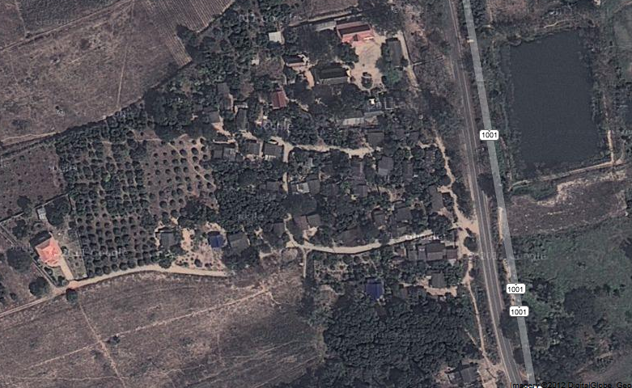

Figure 11 - Map of Upper Section

This portion of the village encompasses 30 of the 159 households. Next, a schematic for the placement of piping was determined based on the layout of the roadways. Figure 9 shows the branched system most appropriate for the households.

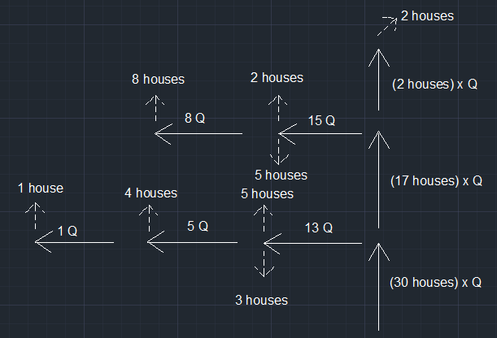

Pipe 6

250 ft.

Pipe 5

350 ft.

Pipe 7 = 275 ft.

Pipe 4 = 200 ft.

Pipe 3

200 ft.

Pipe 2

320 ft.

Pipe 1 445 ft

Figure 12 - Schematic of Upper Section

The solid lines in the picture represent the pipes which were designed, while the dashed lines portray the amount of houses serviced by each pipe. The flow going into each household is equivalent to the annual peak hourly flow per household, or 2.207x10-4cfs, and is represented by “Q”. For example, the first pipe with a flow of “13Q” means that that there was a total flow equivalent to 13 houses worth, or 0.002869cfs. For the hand calculations, the flow for each house lying along one of the 7 2” pipes was said to have exited at the end of that corresponding pipe. This was done to achieve the greatest head loss possible in each pipe because the velocity will be larger than in reality.

The Darcy-Weisbach equation, shown by Equation 7, was used to determine the head loss due to friction throughout pipes 1 through 7. Head losses were calculated using both 1” and 2” diameter pipes to determine the appropriate pipe size for the system.

$Head loss=f\frac{L}{D}\frac{V^{2}}{2g}$ Equation 7

Where:

f = Friction Factor

L = Length of Pipe (ft.)

D = Diameter of Pipe (ft.)

V = Velocity of Water (cfs)

G = Gravitational Constant (32.2 ft/s2)

The friction factor was calculated using Moody’s Diagram (Appendix C) with a combination of Reynold’s Number, Equation 8, and a ratio of the pipe’s roughness coefficient to the diameter, Equation 9.

$Re= \frac{VD}{ν}$ Equation 8

Where:

Re = Reynold’s Number

V = Velocity of Water (cfs)

D = Diameter of Pipe (ft.)

ν = Kinematic Viscosity (ft2/s)

Equation 9

Where:

∈ = Roughness Coefficient (6x10-5 in.)

D = Diameter of Pipe (in.)

After totaling the Head losses relating to the hand calculations, the system was then laid out using the WaterCAD software shown in Figure 10.

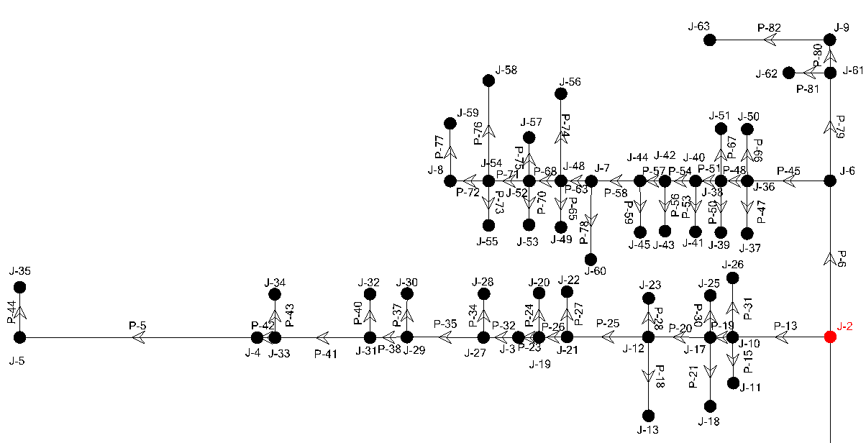

Figure 13 - WaterCAD Schematic for 2” and 3/4" pipes

Using this software, each individual household was able to be branched from one of the seven corresponding pipes at the exact location it rested, instead of at the end of each pipe, contrary to the hand calculations. This yielded more accurate head loss results since the velocity was decreasing along each pipe. Along with these 2” pipes, the 3/4” pipes which lead directly into each home, the 3” pipe from the storage tanks to Route 1001, and finally the 4” pipe running along Route 1001 were also plotted and analyzed. The 3/4" pipe size for each home was determined based on standard distribution systems, the 3” inch line was used based on Kevin’s design in the Hydraulic Design Chapter, and the 4” pipe size was used because of an existing pipe in the village. Information including pipe lengths, flow-rate, minor loss coefficients, and pipe material were entered into the software. The software was then run and the head losses were computed. Appendix F displays the results for each pipe. Figure 11 shows the total upper portion of the system from the storage tanks to each of the 30 households.

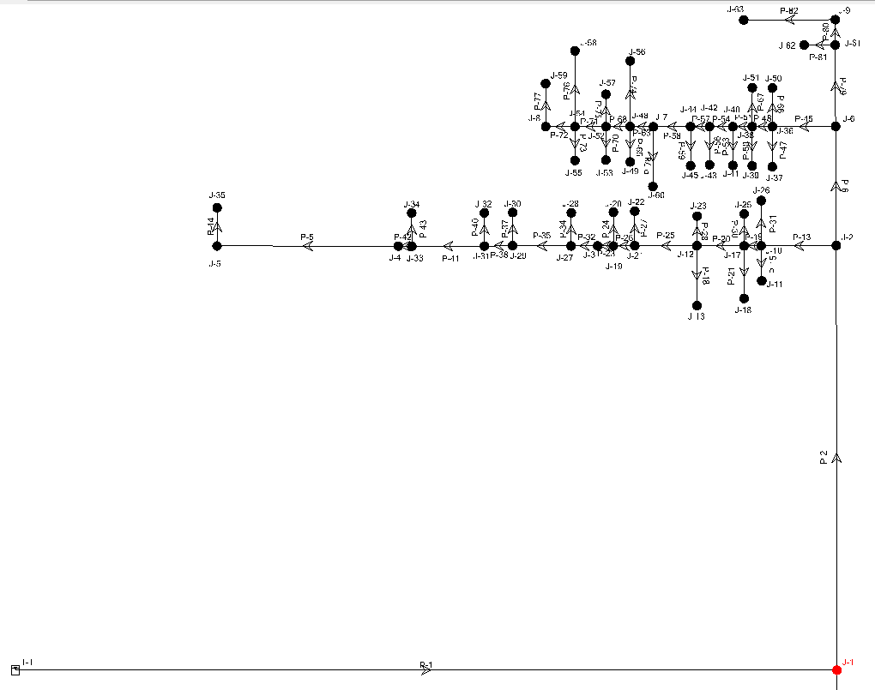

Figure 14 - WaterCAD Schematic for 2” and 3/4" pipes

### Results

Table 5 represents the determined head losses for the hand calculated design. If 1” piping was used for the 7 minor pipes, the overall head loss would equal 3.025 feet. So, a diameter of 2” was chosen for the piping as it yielded a total head loss of only 0.079 feet. These two diameters were chosen and tested according to the minimum diameter needed assuming the maximum velocity in the system was between 10 – 20 ft./s. Minor head losses due to bends, entrances and exits in the system were accounted for by adding an extra 10% head loss to each pipe.

Table 5 - Hand Calculation Results for the Upper 30 houses

|  |  |  |  |  |  |
| --- | --- | --- | --- | --- | --- |
| 1” Diameter | | | 2 “ Diameter | | |
| Pipe | Length (ft.) | Head loss (ft.) | Pipe | Length (ft.) | Head loss (ft.) |
| 1 | 445 | 0.979 | 1 | 445 | 0.0242 |
| 2 | 320 | 0.12 | 2 | 320 | 0.00891 |
| 3 | 200 | .00671 | 3 | 200 | .00022 |
| 4 | 200 | 0.737 | 4 | 200 | 0.0139 |
| 5 | 350 | 1.01 | 5 | 350 | 0.0221 |
| 6 | 250 | 0.135 | 6 | 250 | 0.0084 |
| 7 | 275 | 0.037 | 7 | 275 | 0.00115 |
|  | Total Head loss | 3.025 |  | Total Head loss | 0.079 |

After the 2” diameter was chosen for the local roads, the system was also analyzed in WaterCAD. Table 6 displays the results for the sum of the head losses in the 2” pipes. These values were summed only to compare results with the calculated values achieved by hand. The 0.079 feet of head loss is smaller than the 0.0665 feet from WaterCAD, which was as expected.

Table 6 - WaterCAD 2” Piping Headloss

|  |
| --- |
| Total Head loss (ft.) |
| 0.0665 ft. |

### Conclusion

The overall goal of Senior Project I was successful. The hand calculated results were similar to the WaterCAD output for the 2” pipes servicing 30 of the 159 houses in the village. As expected, the hand calculations yielded higher head losses than WaterCAD. The values were 0.079 feet and 0.0665 feet, respectively. This was due to the fact that in the WaterCAD software, the houses were able to be branched off the 2” pipes exactly where they lie, and not at the ends of each pipe. In other words, there was a decreasing flow along the 2” pipes in WaterCAD. The head losses to any of the 30 individual homes can also be determined by a summation of each of the pipes servicing that home. In the future, the remaining 129 households will be plotted, and the total head loss to each of the 159 homes will be determined to find the most critical path in the system. The approaches that are in progress will lead to the successful completion of the Water Distribution system.







# Conclusion

The overall goal of the Thailand Water Supply System was to pump, store and distribute water to 159 households in Hantham Village of Long Khot, Thailand. The project was divided into three sections which included hydraulics, geotechnical and storage tank design, and a water distribution design. It was determined that the tanks should be located at site 3 of the village, which has an elevation of 86.3 feet. This elevation was able to supply the necessary pressure to the most critical house in the system. The total storage volume of the tanks was designed to be 3,369 ft3 in order to store a 3-day supply of water for the village. The soil sample which was collected on the assessment trip and analyzed was determined to have a unit weight 105lb/ft3 and a friction angle of 30o. The USCS classification was silty or clayey sand. Since there is a lot of error in a small sample size, the minimum soil characteristics were found using an excel spreadsheet. It was determined that the minimum soil properties needed were 80 lb/ft3 and 28o friction angle. The bearing capacity of the estimated properties was 13062.84psf and for the minimum properties it was determined to be 3855.9 psf. The rectangular tank design has the dimensions of 25’x25’x6’ and the circular tank design has a 18’ diameter. For the water distribution portion of the project, the pipe stemming from the storage tank to Route 1001 was designed to be 3”in diameter, the main line running along Route 1001 was determined to be 4” based on an existing pipe in the village, the pipes along each minor road were designed to be 2”, and the pipes branching from the 2” pipes to each home were determined to be 3/4”. The summations of the headlosses in the 2” pipes were found to be 0.079 feet and 0.0665 feet for hand calculated and WaterCAD results, respectively. The hand calculated values were less than the WaterCAD results as expected, because the flows throughout each pipe were not decreasing. In the future, the senior project team will be completing the design of the pump, circular storage tanks, and water distribution system. The results achieved thus far will lead to a successful design at the conclusion of the project.

# List of References

* NILSON, ARTHUR H. *DESIGN OF CONCRETE STRUCTURE.* N.p.: n.p., 1986. Print.
* Chin, David. *Water-Resources Engineering*. 2. 2006. Print.
* Munson, Bruce Roy, Donald F. Young, Theodore H. Okiishi, and Wade W. Huebsch.*Fundamentals Of Fluid Mechanics*. 6th. Jefferson City: John Wiley , 2009. Print.

# Appendix

## Appendix A: Project Overview

### Team Biographies

Stephen Bonk (Team Leader)



Steve Bonk is a senior Civil Engineering major at The College of New Jersey and is from Howell, New Jersey. He is the team leader and his responsibility for the Thailand Water Supply System project is the design of the water distribution system from the storage tanks to each of the 159 households. He is the treasurer of the TCNJ chapter of Engineers without Borders. After graduation, Steve hopes to go into industry as a Civil Engineer and pursue graduate school.

Kevin Dischino



Kevin Dischino is a senior Civil Engineering major with a Mechanical engineering minor at The College of New Jersey and is from Waldwick, New Jersey. He has the responsibility of designing the pump and the necessary elevations for the storage tanks. He is the President of the TCNJ Humanitarian Engineering. After graduation, Kevin hopes to travel to Washington or Colorado for graduate school in Mechanical Engineering.

Joseph Moore



Joseph Moore is a senior Civil Engineering major at The College of New Jersey and is from Delran, New Jersey. He has the responsibility to design the foundation and the concrete storage tanks for the Thailand Water Supply System Project. He is the Fundraising Chair for the TCNJ chapter of Engineers without Borders. After graduation, Joseph hopes to enter industry as a Civil Engineer.

### Engineering standards and realistic constraints form (signed and dated)

### Engineering standards and realistic constraints presentation

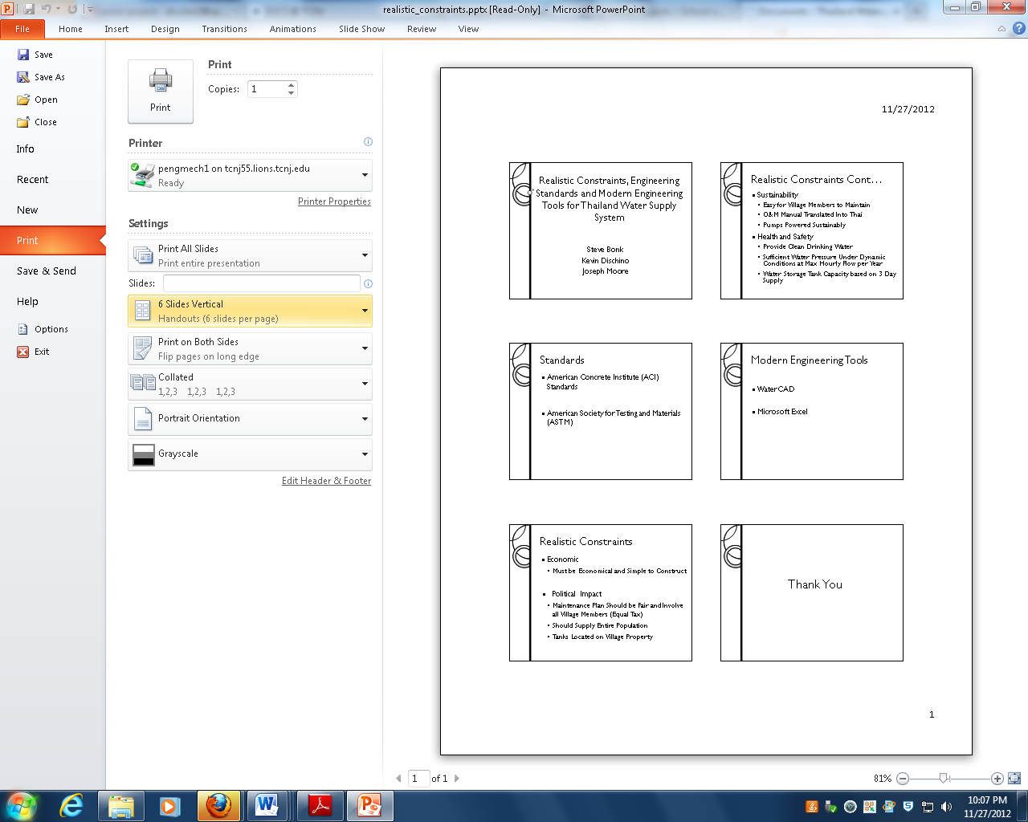

### Engineering standards, specifications and codes (list by name)

* American Concrete Institute (ACI)
* American Society for Testing and Materials (ASTM)
* American Institute of Steel Construction (AISC)

### Modern engineering tools (list by name)

* WaterCAD
* Microsoft Excel

## Appendix B: Team Management

### Gantt chart

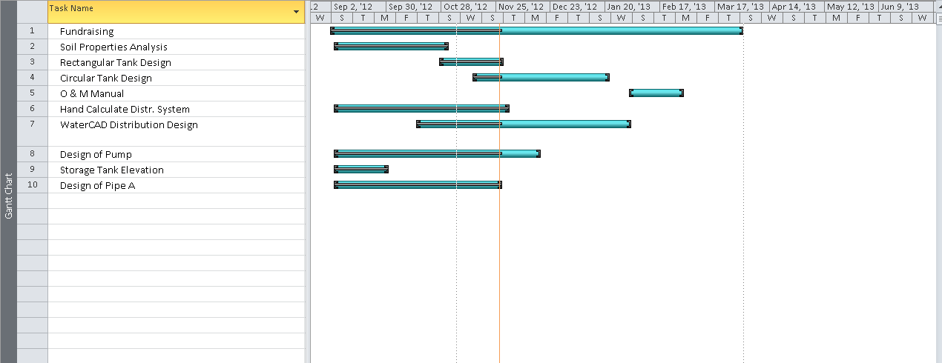

### Meeting minutes (example)

**The College of New Jersey**

**Civil Engineering Department**

**Thailand Water Supply System Senior Project**

Meeting 1: Friday, August 31st, 2012 (Dr. Horst)

Meeting Highlights

* First meeting of the Fall Semester
* Discussed what the main goals of Senior Project are
* Covered the requirements of what goes into the upcoming Proposal Presentation and how it will be evaluated
* Reviewed the Assessment trip to the village in May of 2012 and what was observed/collected
* Determined that entire design should be completed by March 2013, so we can plan a hopeful implementation trip
* Divided and assigned the certain areas of the project to each team member.
  + Kevin – Hydraulics
  + Stephen - Water Distribution System
  + Joseph – Geotechnical Design

For Next Week:

* Complete Proposal Presentation which will be presented to Faculty and Students on Wednesday September 5th, 2012

### List of contacts

* Dr. Michael Shafer
* Dr. Michael Horst
* Dr. Vedrana Krstic
* Dr. Nabil Al-Omaishi

### Safety essay

We will have a few safety considerations to be aware of in order to complete our Thailand Water Supply System project. They mostly stem from the possibility of an implementation trip in May of 2013. We will not need to use any of the machine shops throughout the year. Although we are very eager to help Hantham Village obtain the necessary water they need to survive, we have to first be very careful and cautious with how we approach the problem. Our health and safety should be the number one consideration while we are abroad.

There are many diseases in Thailand which visitors can be easily susceptible to. The appropriate vaccinations must be received before any of us can travel to the village to construct our project. While we are over in Thailand, we also have to be very cautious with where we go or who we interact with. It is an entirely different type of culture which our senior project group is not used to.

As well as traveling to Thailand, we will also be traveling to Atlantic City in March of 2013 to compete in a poster-board competition. Traveling can be dangerous whether it is by car or plane, and we will be cautious with how we move. We will also be carpooling and traveling together to reduce the chances for any type of injury or harm.

Throughout the semester, one of the group members will be using the laboratory to test and classify soil samples. There are many potentially harmful devices and chemicals in the lab, and nothing will be tampered with or used if we are unsure of how to do so. Again, we are extremely excited to help Hantham village by supplying water to them, but we still have to consider each and every safety concern before we act.

### Material list

* Rocks
* Sand
* Concrete
* Metal Reinforcing Rods
* 3” Diameter PVC Pipe
* PVC Glue
* Solar Powered Pumping System

### Financial budget (include all expenses including travel)

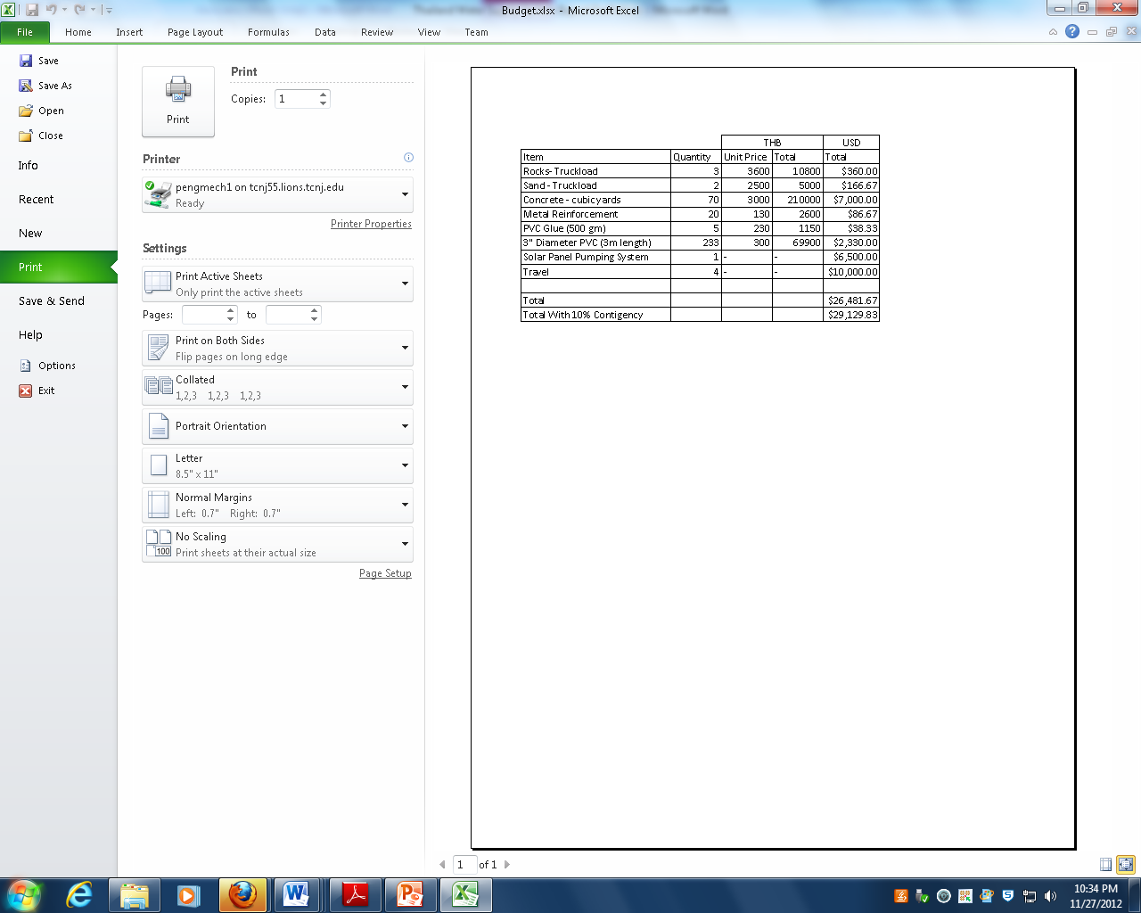

## Appendix C: Moody Diagram

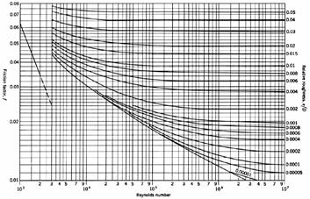

## Appendix D: Topographic Data Map

## Appendix E: System Head Curve Calculations

|  |  |  |  |  |  |  |  |  |  |  |  |  |
| --- | --- | --- | --- | --- | --- | --- | --- | --- | --- | --- | --- | --- |
| Constants | | | | |  |  |  |  |  |  |  |  |
| Roughness Coefficient (in) | | | | 0.00006 |  |  |  |  |  |  |  |  |
| Length pipe (ft) | | | | 778 |  |  |  |  |  |  |  |  |
| Gravity (ft/s^2) | | | | 32.2 |  |  |  |  |  |  |  |  |
| Kinematic Viscosity | | | | 1.21E-05 |  |  |  |  |  |  |  |  |
| Sum Minor Loss Coefficients | | | | 7 |  |  |  |  |  |  |  |  |
|  | | |  |  |  |  |  |  |  |  |  |  |
|  | | |  |  |  |  |  |  |  |  |  |  |
| Diameter Pipe | | | | 1.00 | in |  |  |  |  |  |  |  |
| Q (gpm) | | Q (ft^3/s) | | V (ft/s) | Velocity Head (ft) | E/D | Reynolds | Friction Factor | Minor Head Loss (ft) | Major Head Loss (ft) | Elevation Head (ft) | Pump Energy (ft) |
| 0.0 | | 0 | | 0.00 | 0.000 | 0.00006 | 0.00E+00 | 0 | 0.00 | 0.00 | 424.4 | 424.40 |
| 2.2 | | 0.005 | | 0.92 | 0.013 | 0.00006 | 6.31E+03 | 0.036 | 0.09 | 4.39 | 424.4 | 428.89 |
| 4.5 | | 0.01 | | 1.83 | 0.052 | 0.00006 | 1.26E+04 | 0.029 | 0.37 | 14.13 | 424.4 | 438.95 |
| 5.8 | | 0.013 | | 2.38 | 0.088 | 0.00006 | 1.64E+04 | 0.028 | 0.62 | 23.06 | 424.4 | 448.17 |
| 6.7 | | 0.015 | | 2.75 | 0.117 | 0.00006 | 1.89E+04 | 0.027 | 0.82 | 29.61 | 424.4 | 454.94 |
| 9.0 | | 0.02 | | 3.67 | 0.209 | 0.00006 | 2.53E+04 | 0.025 | 1.46 | 48.73 | 424.4 | 474.80 |
| 11.2 | | 0.025 | | 4.58 | 0.326 | 0.00006 | 3.16E+04 | 0.024 | 2.28 | 73.10 | 424.4 | 500.11 |
| 13.5 | | 0.03 | | 5.50 | 0.470 | 0.00006 | 3.79E+04 | 0.023 | 3.29 | 100.88 | 424.4 | 529.04 |
| 15.7 | | 0.035 | | 6.42 | 0.639 | 0.00006 | 4.42E+04 | 0.022 | 4.48 | 131.33 | 424.4 | 560.85 |
| 18.0 | | 0.04 | | 7.33 | 0.835 | 0.00006 | 5.05E+04 | 0.0215 | 5.85 | 167.64 | 424.4 | 598.72 |
| 20.2 | | 0.045 | | 8.25 | 1.057 | 0.00006 | 5.68E+04 | 0.021 | 7.40 | 207.24 | 424.4 | 640.09 |
| 22.4 | | 0.05 | | 9.17 | 1.305 | 0.00006 | 6.31E+04 | 0.0205 | 9.13 | 249.76 | 424.4 | 684.60 |
|  | |  | |  |  |  |  |  |  |  |  |  |
|  | |  | |  |  |  |  |  |  |  |  |  |
| Diameter Pipe | | | | 2.00 | in |  |  |  |  |  |  |  |
| Q (gpm) | Q (ft^3/s) | | | V (ft/s) | Velocity Head (ft) | E/D | Reynolds | Friction Factor | Minor Head Loss (ft) | Major Head Loss (ft) | Elevation Head (ft) | Pump Energy (ft) |
| 0.0 | 0 | | | 0.00 | 0.000 | 0.00003 | 0.00E+00 | 0 | 0.00 | 0.00 | 424.4 | 424.40 |
| 2.2 | 0.005 | | | 0.23 | 0.001 | 0.00003 | 3.16E+03 | 0.047 | 0.01 | 0.18 | 424.4 | 424.59 |
| 4.5 | 0.01 | | | 0.46 | 0.003 | 0.00003 | 6.31E+03 | 0.032 | 0.02 | 0.49 | 424.4 | 424.91 |
| 5.8 | 0.013 | | | 0.60 | 0.006 | 0.00003 | 8.21E+03 | 0.0315 | 0.04 | 0.81 | 424.4 | 425.25 |
| 6.7 | 0.015 | | | 0.69 | 0.007 | 0.00003 | 9.47E+03 | 0.031 | 0.05 | 1.06 | 424.4 | 425.52 |
| 9.0 | 0.02 | | | 0.92 | 0.013 | 0.00003 | 1.26E+04 | 0.03 | 0.09 | 1.83 | 424.4 | 426.33 |
| 11.2 | 0.025 | | | 1.15 | 0.020 | 0.00003 | 1.58E+04 | 0.029 | 0.14 | 2.76 | 424.4 | 427.32 |
| 13.5 | 0.03 | | | 1.38 | 0.029 | 0.00003 | 1.89E+04 | 0.027 | 0.21 | 3.70 | 424.4 | 428.34 |
| 15.7 | 0.035 | | | 1.60 | 0.040 | 0.00003 | 2.21E+04 | 0.0245 | 0.28 | 4.57 | 424.4 | 429.29 |
| 18.0 | 0.04 | | | 1.83 | 0.052 | 0.00003 | 2.53E+04 | 0.024 | 0.37 | 5.85 | 424.4 | 430.67 |
| 20.2 | 0.045 | | | 2.06 | 0.066 | 0.00003 | 2.84E+04 | 0.0235 | 0.46 | 7.25 | 424.4 | 432.18 |
| 22.4 | 0.05 | | | 2.29 | 0.082 | 0.00003 | 3.16E+04 | 0.023 | 0.57 | 8.76 | 424.4 | 433.81 |
|  |  | | |  |  |  |  |  |  |  |  |  |
| Diameter Pipe | | | | 3.00 | in |  |  |  |  |  |  |  |
| Q (gpm) | Q (ft^3/s) | | | V (ft/s) | Velocity Head (ft) | E/D | Reynolds | Friction Factor | Minor Head Loss (ft) | Major Head Loss (ft) | Elevation Head (ft) | Pump Energy (ft) |
| 0.0 | 0 | | | 0.00 | 0.000 | 0.00002 | 0.00E+00 | 0 | 0.00 | 0.00 | 424.4 | 424.40 |
| 2.2 | 0.005 | | | 0.10 | 0.000 | 0.00002 | 2.10E+03 | 0.031 | 0.00 | 0.02 | 424.4 | 424.42 |
| 4.5 | 0.01 | | | 0.20 | 0.001 | 0.00002 | 4.21E+03 | 0.04 | 0.00 | 0.08 | 424.4 | 424.49 |
| 5.8 | 0.013 | | | 0.26 | 0.001 | 0.00002 | 5.47E+03 | 0.039 | 0.01 | 0.13 | 424.4 | 424.54 |
| 6.7 | 0.015 | | | 0.31 | 0.001 | 0.00002 | 6.31E+03 | 0.0325 | 0.01 | 0.15 | 424.4 | 424.56 |
| 9.0 | 0.02 | | | 0.41 | 0.003 | 0.00002 | 8.42E+03 | 0.0315 | 0.02 | 0.25 | 424.4 | 424.67 |
| 11.2 | 0.025 | | | 0.51 | 0.004 | 0.00002 | 1.05E+04 | 0.0305 | 0.03 | 0.38 | 424.4 | 424.81 |
| 13.5 | 0.03 | | | 0.61 | 0.006 | 0.00002 | 1.26E+04 | 0.0295 | 0.04 | 0.53 | 424.4 | 424.98 |
| 15.7 | 0.035 | | | 0.71 | 0.008 | 0.00002 | 1.47E+04 | 0.029 | 0.06 | 0.71 | 424.4 | 425.18 |
| 18.0 | 0.04 | | | 0.81 | 0.010 | 0.00002 | 1.68E+04 | 0.0285 | 0.07 | 0.91 | 424.4 | 425.40 |
| 20.2 | 0.045 | | | 0.92 | 0.013 | 0.00002 | 1.89E+04 | 0.0265 | 0.09 | 1.08 | 424.4 | 425.58 |
| 22.4 | 0.05 | | | 1.02 | 0.016 | 0.00002 | 2.10E+04 | 0.0255 | 0.11 | 1.28 | 424.4 | 425.81 |

## Appendix F: WaterCAD Output

|  |  |  |  |  |  |  |  |  |
| --- | --- | --- | --- | --- | --- | --- | --- | --- |
| Pipe | Start Node | Stop Node | Diameter (in) | Material | Flow (cfs) | Headloss Gradient (ft/ft) | Length (ft) | Headloss (ft) |
| P-1 | T-1 | J-1 | 3 | PVC | 0.035091 | 0.000867 | 1,903 | 1.649901 |
| P-2 | J-1 | J-2 | 4 | PVC | 0.006621 | 0.000008 | 853 | 0.006824 |
| P-5 | J-4 | J-5 | 2 | PVC | 0.000221 | 0.000004 | 200 | 0.0008 |
| P-6 | J-2 | J-6 | 2 | PVC | 0.003752 | 0.000083 | 200 | 0.0166 |
| P-13 | J-2 | J-10 | 2 | PVC | 0.002869 | 0.000052 | 150 | 0.0078 |
| P-15 | J-10 | J-11 | 0.75 | PVC | 0.000221 | 0.000198 | 25 | 0.00495 |
| P-18 | J-12 | J-13 | 0.75 | PVC | 0.000221 | 0.000198 | 100 | 0.0198 |
| P-19 | J-10 | J-17 | 2 | PVC | 0.002428 | 0.000046 | 30 | 0.00138 |
| P-20 | J-17 | J-12 | 2 | PVC | 0.001986 | 0.000036 | 85 | 0.00306 |
| P-21 | J-17 | J-18 | 0.75 | PVC | 0.000221 | 0.000198 | 80 | 0.01584 |
| P-23 | J-19 | J-3 | 2 | PVC | 0.001104 | 0.00002 | 25 | 0.0005 |
| P-24 | J-19 | J-20 | 0.75 | PVC | 0.000221 | 0.000202 | 25 | 0.00505 |
| P-25 | J-12 | J-21 | 2 | PVC | 0.001545 | 0.000028 | 115 | 0.00322 |
| P-26 | J-21 | J-19 | 2 | PVC | 0.001324 | 0.000024 | 40 | 0.00096 |
| P-27 | J-21 | J-22 | 0.75 | PVC | 0.000221 | 0.000202 | 25 | 0.00505 |
| P-28 | J-12 | J-23 | 0.75 | PVC | 0.000221 | 0.0002 | 25 | 0.005 |
| P-30 | J-17 | J-25 | 0.75 | PVC | 0.000221 | 0.0002 | 25 | 0.005 |
| P-31 | J-10 | J-26 | 0.75 | PVC | 0.000221 | 0.000198 | 40 | 0.00792 |
| P-32 | J-3 | J-27 | 2 | PVC | 0.001104 | 0.00002 | 40 | 0.0008 |
| P-34 | J-27 | J-28 | 0.75 | PVC | 0.000221 | 0.000202 | 25 | 0.00505 |
| P-35 | J-27 | J-29 | 2 | PVC | 0.000883 | 0.000016 | 100 | 0.0016 |
| P-37 | J-29 | J-30 | 0.75 | PVC | 0.000221 | 0.000202 | 25 | 0.00505 |
| P-38 | J-29 | J-31 | 2 | PVC | 0.000662 | 0.000012 | 40 | 0.00048 |
| P-40 | J-31 | J-32 | 0.75 | PVC | 0.000221 | 0.000202 | 25 | 0.00505 |
| P-41 | J-31 | J-33 | 2 | PVC | 0.000441 | 0.000008 | 120 | 0.00096 |
| P-42 | J-33 | J-4 | 2 | PVC | 0.000221 | 0.000004 | 20 | 0.00008 |
| P-43 | J-33 | J-34 | 0.75 | PVC | 0.000221 | 0.000202 | 25 | 0.00505 |
| P-44 | J-5 | J-35 | 0.75 | PVC | 0.000221 | 0.000198 | 80 | 0.01584 |
| P-45 | J-6 | J-36 | 2 | PVC | 0.003311 | 0.000067 | 100 | 0.0067 |
| P-47 | J-36 | J-37 | 0.75 | PVC | 0.000221 | 0.000199 | 40 | 0.00796 |
| P-48 | J-36 | J-38 | 2 | PVC | 0.002869 | 0.000054 | 40 | 0.00216 |
| P-50 | J-38 | J-39 | 0.75 | PVC | 0.000221 | 0.000195 | 40 | 0.0078 |
| P-51 | J-38 | J-40 | 2 | PVC | 0.002428 | 0.000045 | 40 | 0.0018 |
| P-53 | J-40 | J-41 | 2 | PVC | 0.000221 | 0.000004 | 40 | 0.00016 |
| P-54 | J-40 | J-42 | 2 | PVC | 0.002207 | 0.00004 | 60 | 0.0024 |
| P-56 | J-42 | J-43 | 0.75 | PVC | 0.000221 | 0.0002 | 40 | 0.008 |
| P-57 | J-42 | J-44 | 2 | PVC | 0.001986 | 0.000036 | 40 | 0.00144 |
| P-58 | J-44 | J-7 | 2 | PVC | 0.001766 | 0.000032 | 70 | 0.00224 |
| P-59 | J-44 | J-45 | 0.75 | PVC | 0.000221 | 0.0002 | 40 | 0.008 |
| P-63 | J-7 | J-48 | 2 | PVC | 0.001545 | 0.000027 | 50 | 0.00135 |
| P-65 | J-48 | J-49 | 0.75 | PVC | 0.000221 | 0.0002 | 25 | 0.005 |
| P-66 | J-36 | J-50 | 0.75 | PVC | 0.000221 | 0.0002 | 25 | 0.005 |
| P-67 | J-38 | J-51 | 0.75 | PVC | 0.000221 | 0.0002 | 25 | 0.005 |
| P-68 | J-48 | J-52 | 2 | PVC | 0.001104 | 0.00002 | 50 | 0.001 |
| P-70 | J-52 | J-53 | 0.75 | PVC | 0.000221 | 0.0002 | 25 | 0.005 |
| P-71 | J-52 | J-54 | 2 | PVC | 0.000662 | 0.000012 | 75 | 0.0009 |
| P-72 | J-54 | J-8 | 2 | PVC | 0.000221 | 0.000004 | 75 | 0.0003 |
| P-73 | J-54 | J-55 | 0.75 | PVC | 0.000221 | 0.0002 | 30 | 0.006 |
| P-74 | J-48 | J-56 | 0.75 | PVC | 0.000221 | 0.000198 | 100 | 0.0198 |
| P-75 | J-52 | J-57 | 0.75 | PVC | 0.000221 | 0.0002 | 25 | 0.005 |
| P-76 | J-54 | J-58 | 0.75 | PVC | 0.000221 | 0.000198 | 120 | 0.02376 |
| P-77 | J-8 | J-59 | 0.75 | PVC | 0.000221 | 0.000198 | 40 | 0.00792 |
| P-78 | J-7 | J-60 | 0.75 | PVC | 0.000221 | 0.000198 | 100 | 0.0198 |
| P-79 | J-6 | J-61 | 2 | PVC | 0.000441 | 0.000008 | 210 | 0.00168 |
| P-80 | J-61 | J-9 | 2 | PVC | 0.000221 | 0.000004 | 65 | 0.00026 |
| P-81 | J-61 | J-62 | 0.75 | PVC | 0.000221 | 0.000202 | 25 | 0.00505 |
| P-82 | J-9 | J-63 | 0.75 | PVC | 0.000221 | 0.000198 | 100 | 0.0198 |

## Appendix G: Evaluations